Practical 1
Question:
Write a C program that reads a command from the user, creates a child process using fork(), and executes the entered command in the child process using execlp(). The parent process should display its own PID along with the child's PID and wait for the child to finish before terminating.
Code:
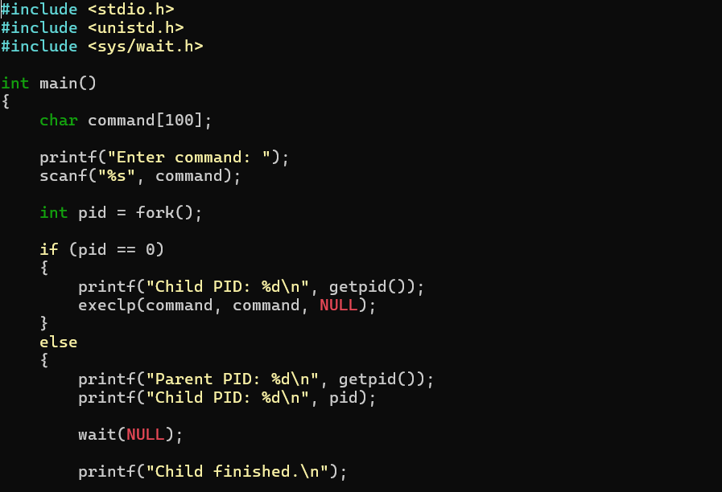
Output:
